**Sales Tax Data Import from Zip2Tax**

**Summary**

Each month we download sales tax data from Zip2Tax and load to a SQL table for use by accounting when updating Syspro’s tax data. Should be completed the last week of each month (sometimes data is not available until 2-3 days before the end of the month).

**Step by Step**

1. Go to <https://zip2tax.com/> and click Login
   1. Username: sumclascon
   2. Password: 36al11
2. From My Account menu to Table Download
3. You should see the upcoming month’s information. Click Download
   1. Example below for June. Shows June at the bottom and 06 in the file name along with Last Download being Never

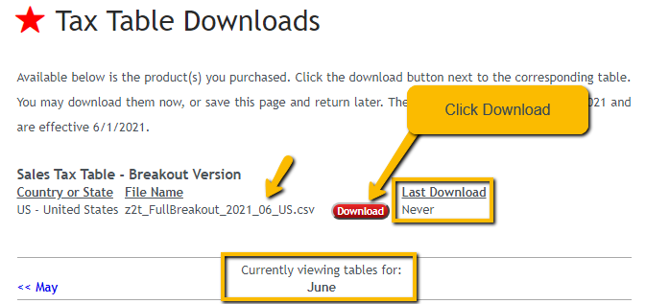

1. Open SQL Server Management Studio and Connect to SQL08
2. Right click on the Zip2Tax database and select Tasks > Import Data

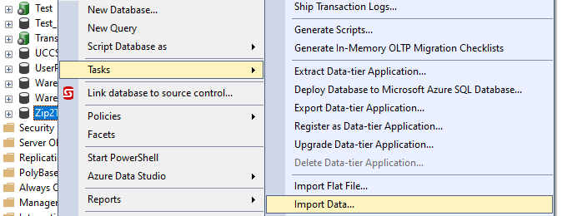

1. Click Next

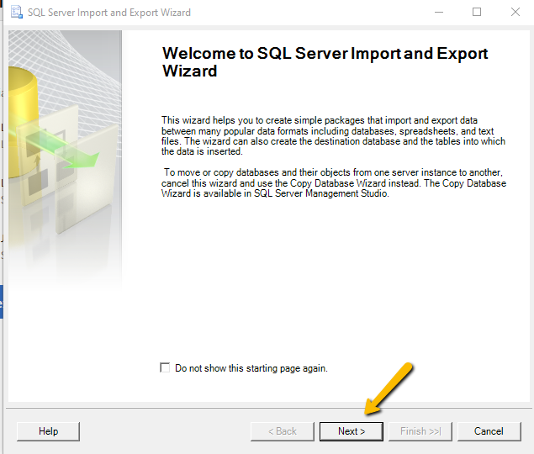

1. Select Flat File Source and click Next

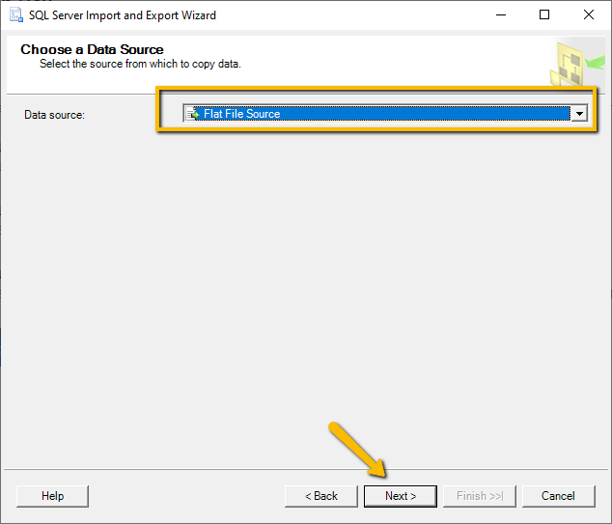

1. Click Browse and find the file you downloaded then click Next. ***Note you will need to change the default file type to .csv or All when browsing to see the file downloaded as the default is .txt

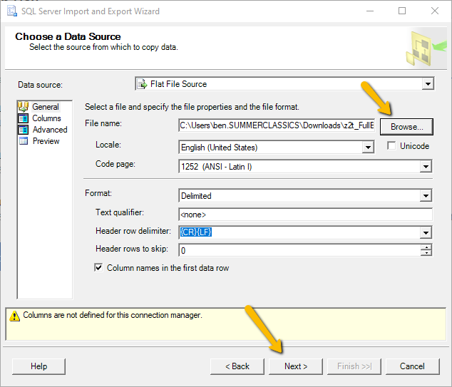

1. Click Next

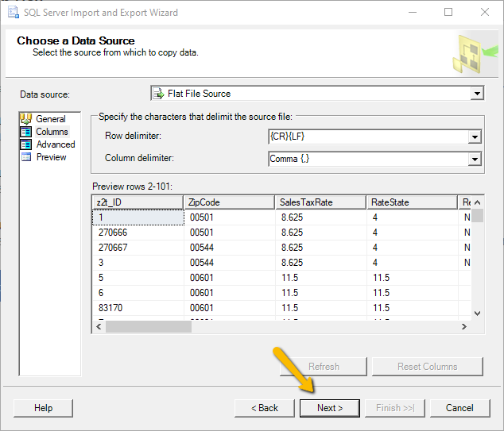

1. Select SQL Server Native Client 11.0 as the Destination. Then click Next

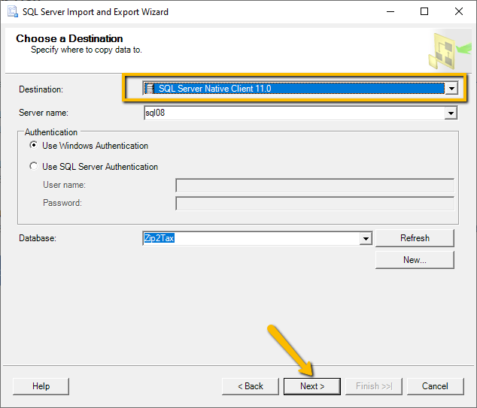

1. Click Next

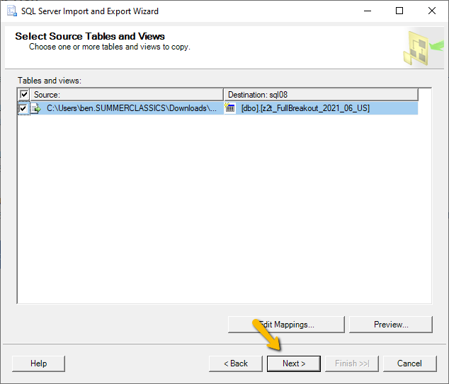

1. Click Next

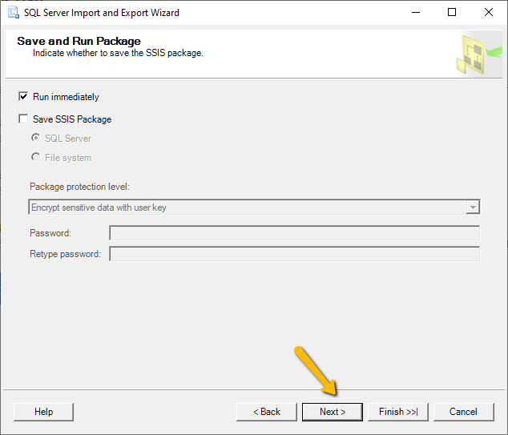

1. Click Finish

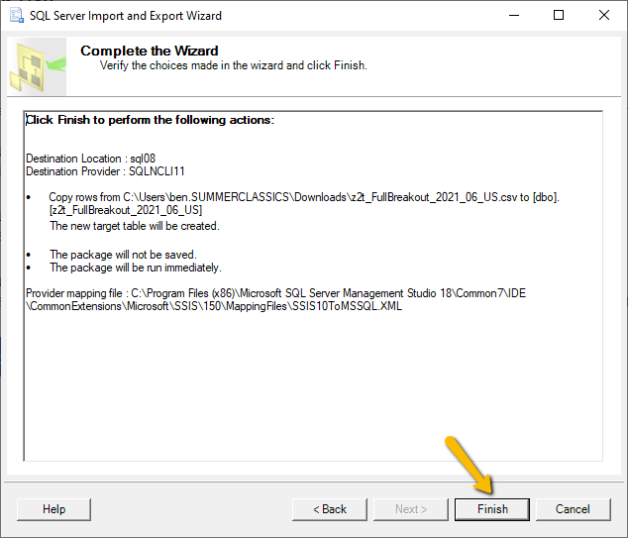

1. Expand the Zip2Tax database and expand the Tables menu.
2. Right click on dbo.YearMonth and select Edit

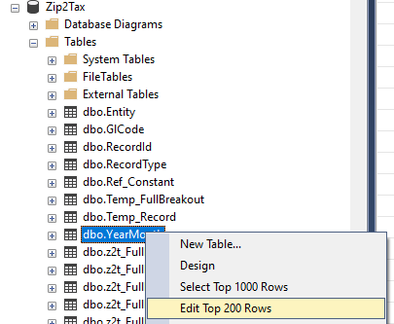

1. Scroll to end and input the 4 digit Year and 2 digit Month for the file just imported.

